A guide to ordering Royal Mail uniform -

A new ordering platform has launched for Royal Mail called DETAIL this will enable you to place orders online at your own convenience, anytime, anywhere from any device.

Detail Link -
https://detail.dimensions.co.uk/RoyalMail
Once you have clicked on the link above you will see the following screen where you will be prompted to enter your username and password, if this is the first time you are logging on you will be asked to provide a valid email address and contact number, by adding these details to your profile you will be able to be kept up to date with the process of your order. –
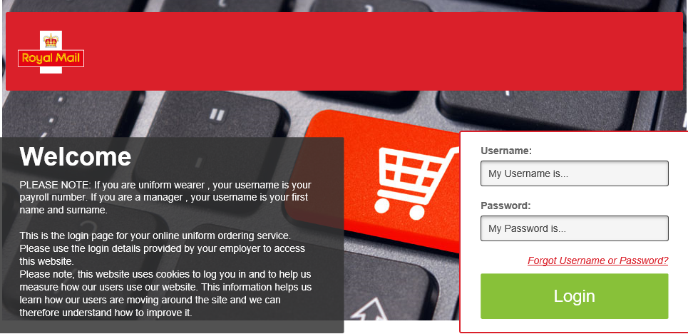
Once you have logged in you will see a notices page. This page will show all the important messages regarding your uniform. Once you have read the notices, click you have read the notices.

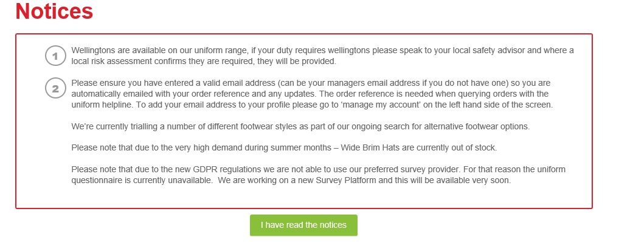
You should now see your welcome page, from here you will be able to – view your catalogue, place and order, view your order history and order status updates, allocation allowance and LIVE stock availability. To place your order click on order my uniform –

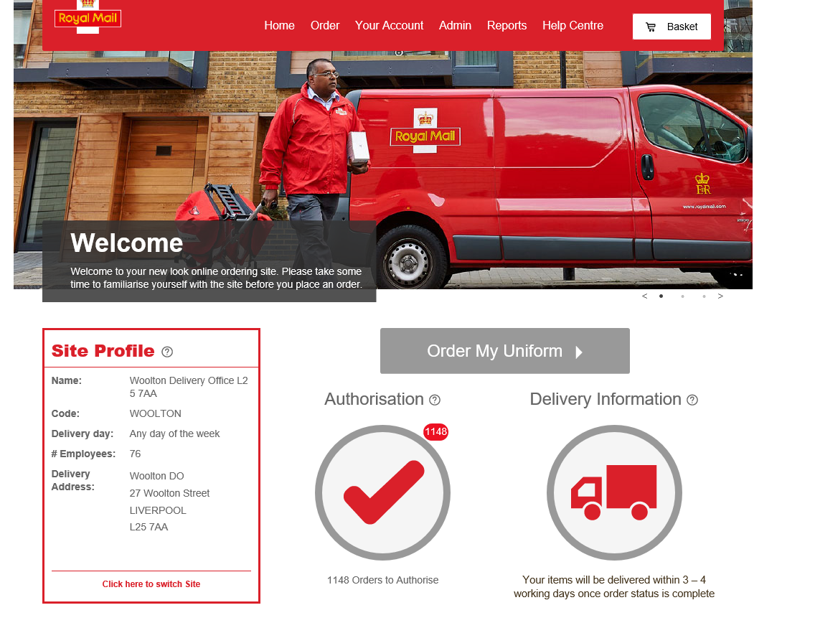
You should now see products which are available to order, shown by category, you can either click on the image related to the category you wish to order or select from the menu on the left hand side.
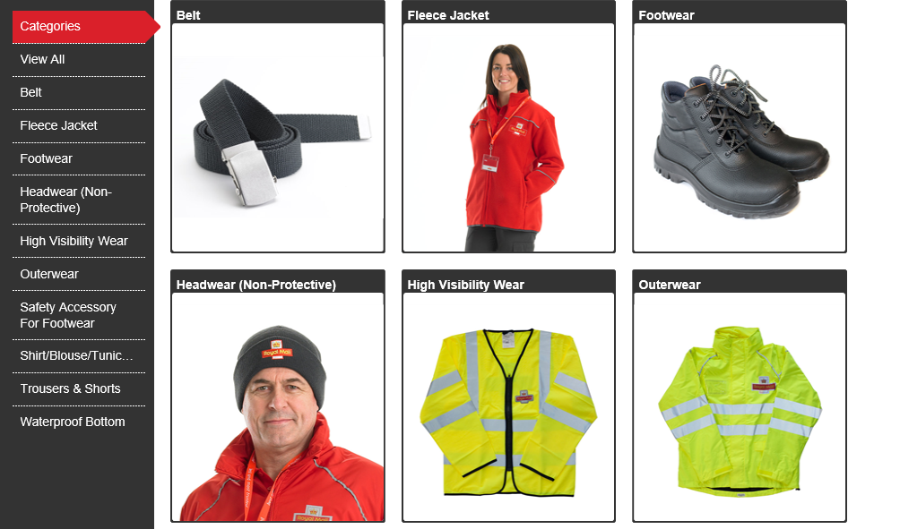
Once you have selected the category you want to order from, you will be shown all the products available to you within that category. The allocation bar shown what allocation is remaining for each item that you select. To the right of the allocation bar you can also see when your next allocation is due and if you have added items to your basket which are over allocation.

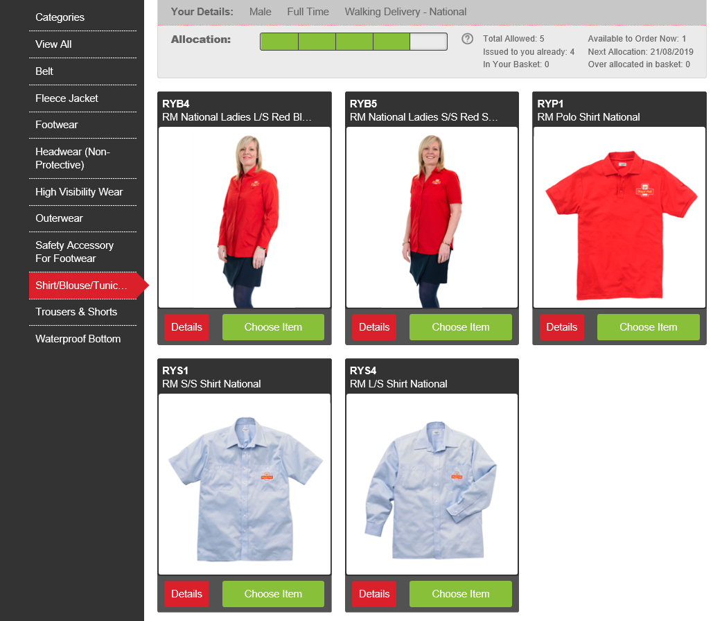

Once you have clicked on the image you wish to order you will need to click on the drop down arrow, select your size, select how many you wish to order then click add to basket.
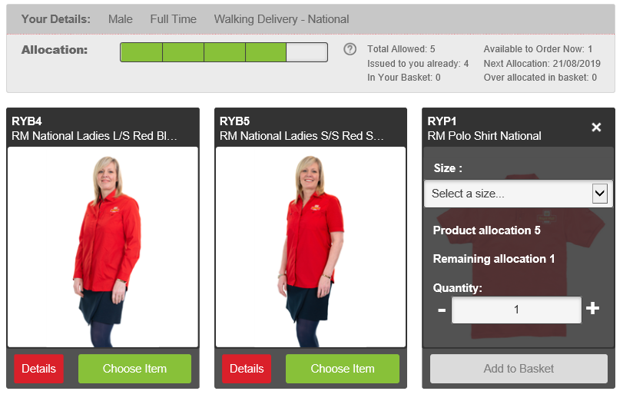

Once you have clicked add to basket and finished ordering the items you require, you will need to scroll to the top of the page, at the top right of the page you will need to click on the basket icon which will take you to the following page –

Click on the green check out button, if you are within entitlement you will see the following screen, on the left hand side you will see where the items are being delivered, and to the right you will see manager’s name and Notes box. You need to put your manager’s name and in the notes you will need to add a comment whether they are within entitlement, size exchange etc. These are required fields if you do not add your manager’s name or comments in the notes box your order will not go through.

If you are ordering items which are over entitlement, you will see the following screen –
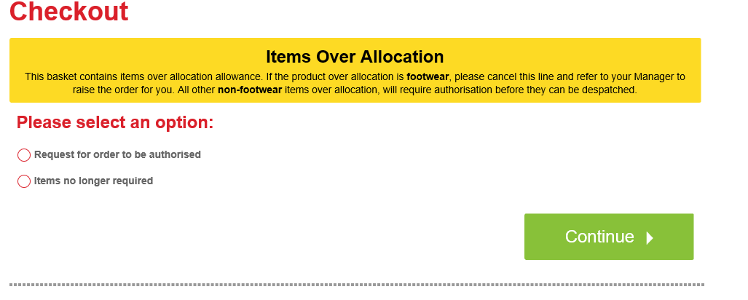
Please click in the circle, request for order to be authorised, then click continue, you will then see the following screen, This will give you an overview of what you have ordered that’s over entitlement and that will be sent to the Demand Challenge Team within Royal Mail for them to review and authorise/decline, please click the continue button.

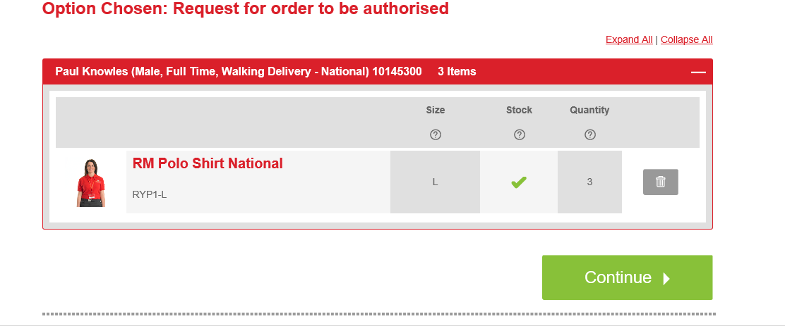

Once you have clicked continue you will see the checkout screen which summarises the details of your order, your delivery address, you will need to add your managers name in the box and also in the notes field include a detailed explanation advising the reasons for ordering outside of your allocation, worn and torn isn’t a detailed reason for the Demand challenge team to authorise. Then click place order where you will be given an Order Reference number, this can then be used to check the status of your order.

