Stake:
£XX
Total pot:
£XX
Top prize:
£XX
Cut out the team names, fold them and put them in a hat for entrants to draw out.
At the end of the tournament, the person with the UEFA Euro winning team wins. We are donating [XX]% to the BHF and the rest is prize money!

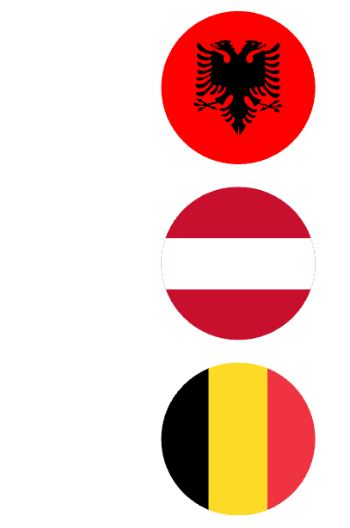  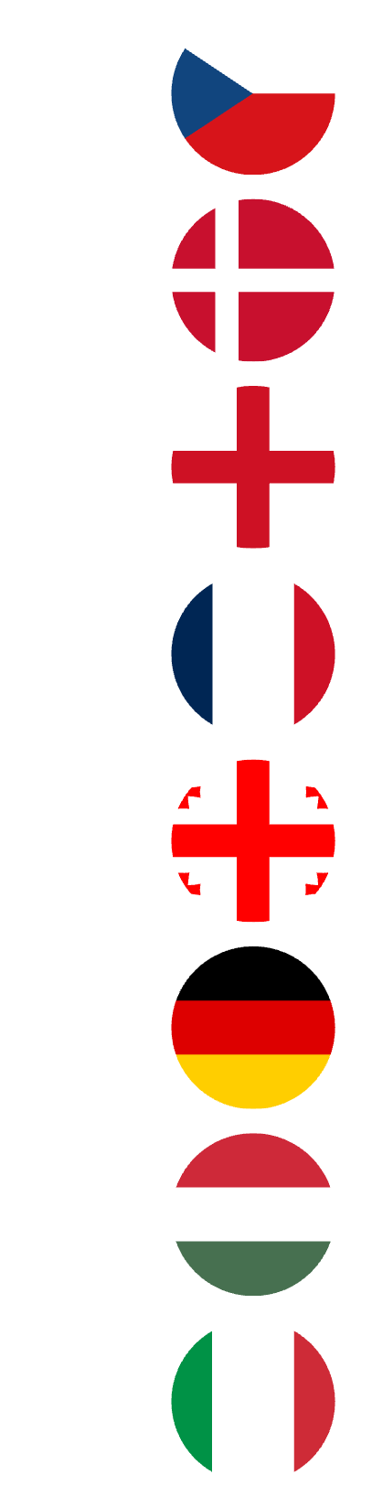  Albania | 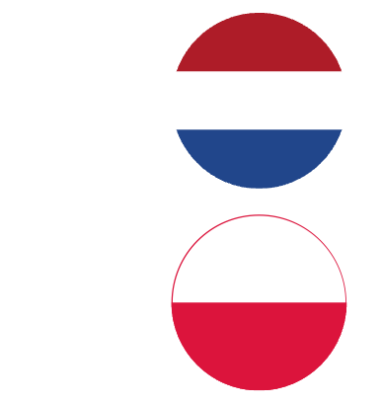  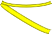  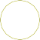  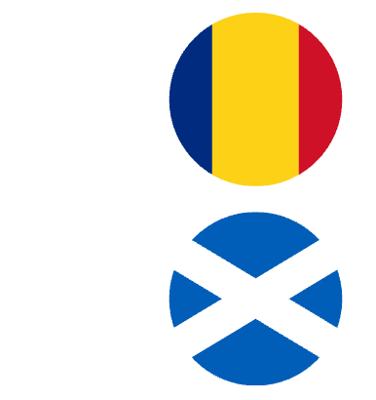  Netherlands
Austria | Poland
Belgium | 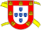  Portugal
Croatia | Romania
Czechia | Scotland
Denmark | 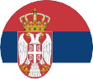  Serbia
England |   Slovakia
France | Slovenia
Georgia | 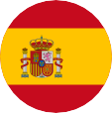  Spain
Germany | 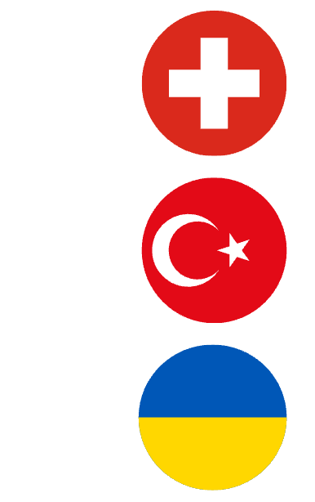  Switzerland
Hungary | Türkiye
Italy | Ukraine

Albania
Austria
Belgium
Croatia
Czechia
Denmark
England
France
Georgia
Germany
Hungary
Italy
Netherlands
Poland
Portugal
Romania
Scotland
Serbia
Slovakia
Slovenia
Spain
Switzerland
Türkiye
Ukraine

Write in the person’s name next to their selected team and take the donation at the time of selection.
At the end of the tournament, the person with the UEFA EURO
winning team next to their entry name wins. We are
donating [XX]% to
the BHF and the rest is prize money!

Stake:
£XX
Total pot:
£XX
Top prize:
£XX

Albania
Austria
Belgium
Croatia
Czechia
Denmark
England
France
Georgia
Germany
Hungary
Italy
Netherlands
Poland
Portugal
Romania
Scotland
Serbia
Slovakia
Slovenia
Spain
Switzerland
Türkiye
Ukraine

Write in the person’s name next to their selected team and take the donation at the time of selection.
At the end of the tournament, the person with the UEFA EURO
winning team next to their entry name wins. We are
donating [XX]% to
the BHF and the rest is prize money!

Stake:
£XX
Total pot:
£XX
Top prize:
£XX

