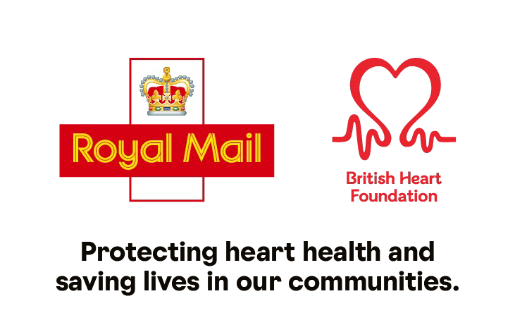**Join our**

**UEFA Euro 2024**

**sweepstake!**

Raise money for our national charity partner, British Heart Foundation (BHF)

[INSERT DESCRIPTION OF SWEEPTSTAKE BEING RUN]

The winner keeps a percentage with the rest donated to BHF, to help protect heart health and save lives in our communities.

Contact [INSERT NAME] at [CONTACT DETAILS]

to find out more.

**bhf.org.uk**

©British Heart Foundation, a registered charity in England and Wales (225971) and Scotland (SC039426)

