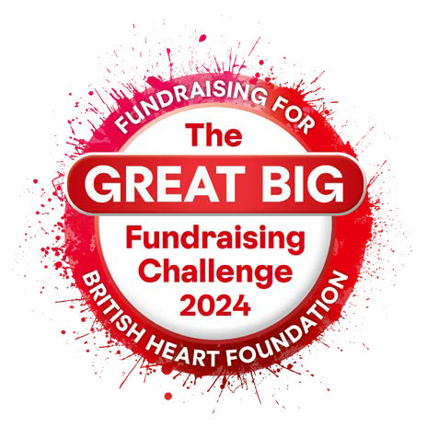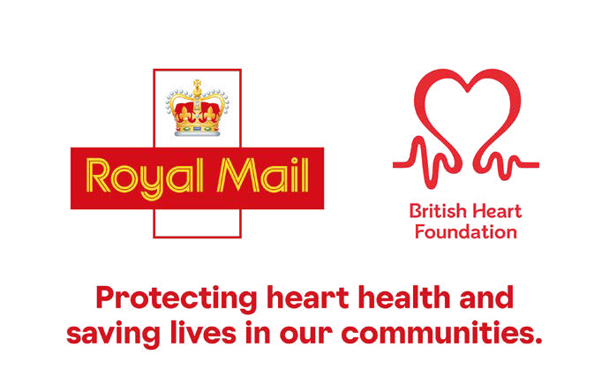The Great Big Fundraising Challenge

Sponsorship form

The Great Big Fundraising Challenge pits teams against each other in a fundraising competition over three months in a race to raise vital funds for British Heart Foundation (BHF) and be crowned Royal Mail’s best fundraising team. These funds will go towards the Community Hearts Programme which will help protect heart health and save lives in our communities.

This sponsorship form can be used to raise funds for BHF.

Team Name:

Fundraiser’s Name:

# Make your gift work harder

Do you pay tax? If so, simply by completing this form and ticking this box you can boost the value of your gift by 25p for every £1 without costing you a penny.

*If I have ticked the box headed ‘Gift Aid’, I confirm that I am a UK Income or Capital Gains taxpayer. I have read this statement and want the BHF to reclaim tax on the donation detailed below, given on the date shown. I

understand that if I pay less Income Tax/ or Capital Gains tax in the current year than the amount of Gift Aid claimed on all of my donations it is my responsibility to pay any difference. I understand the BHF will reclaim 25p of tax on every £1 that I have given.

|  |  |  |  |  |
| --- | --- | --- | --- | --- |
| Full name | Full home address and postcode | Gift Aid | Amount pledged | Date given |
|  |  |  | £ |  |
|  |  |  | £ |  |
|  |  |  | £ |  |
|  |  |  | £ |  |
|  |  |  | £ |  |
|  |  |  | £ |  |
|  |  |  | £ |  |

|  |  |  |  |  |
| --- | --- | --- | --- | --- |
| Full name | Full home address and postcode | Gift Aid | Amount pledged | Date given |
|  |  |  | £ |  |
|  |  |  | £ |  |
|  |  |  | £ |  |
|  |  |  | £ |  |
|  |  |  | £ |  |
|  |  |  | £ |  |
|  |  |  | £ |  |
|  |  |  | £ |  |
|  |  |  | £ |  |
|  |  |  | £ |  |
|  |  |  | £ |  |
|  |  |  | £ |  |

Checklist for fundraisers

1. Provide your online Sponsor Me Fundraising Page to sponsors who want to donate online.
2. Cash and cheques should be banked at any Post Office branch using a dedicated paying-in-slip for your team. Please contact your team lead for paying-in-slips. Alternatively, you can request one from the BHF team by emailing [britishheartfoundation@royalmail.com](http://britishheartfoundation@royalmail.com/)
3. Cheques should be made out to Charities Trust who administer fundraising on behalf of Royal Mail and will transfer 100% of your funds to BHF. Please write your name on the back of cheques if you are sending with this form.
4. Once you have completed this form, attach your Post Office deposit receipts or cheque and send it to:

Charities Trust Suite 20 – 22 Century Building Tower Street Liverpool L3 4BJ