|  |  |
| --- | --- |
| Details |  |
| Site Name/Type |  |
| Contact Name / Role |  |
| Contact Number |  |
| Delivery Address |  |
| Please return this form to: | Laura Scholey <laura.scholey@royalmail.com> |

|  |  |  |  |
| --- | --- | --- | --- |
| Straps | Model | Part Number | Volume Required |
| Full Strap Assembly | Mk2 York | VXK45425 |  |
| Full Strap Assembly | Mk3 York | RCS2185 |  |

|  |  |  |  |
| --- | --- | --- | --- |
| Repair Straps | Model | Part Number | Volume Required |
| Webbing Repair Strap | Mk2 York | VXS6493 |  |
| Buckle Repair Strap | Mk2 & Mk3 York | RCS2185 |  |

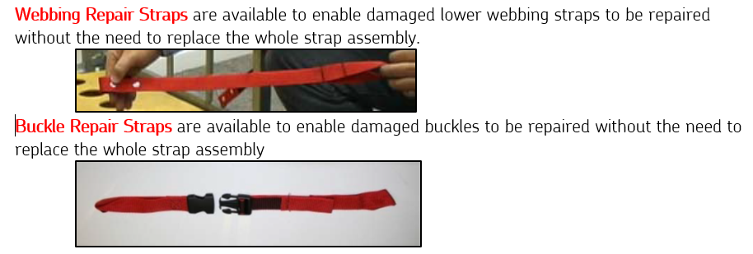

|  |
| --- |
| Other Requests Comments |
|  |